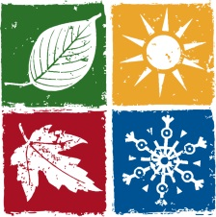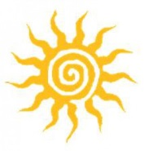In which season…
The air is fresh and people go for walk in… | SPRING
People have to wear warm clothing, caps and gloves in …
Christmas is celebrated in …
It is often rainy and windy in…
The days are long and nights are short in…
The roads become icy and slippery in…
First flowers appear – snowdrops and snowflakes in…

The sky is clear and bright in…
Children have two months holidays in…
Snow starts to melt, the grass starts to grow in…
The nights are shorter and the days get longer in… | 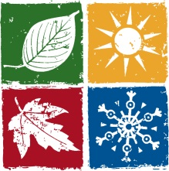
Easter is celebrated in…
Children fly kites and go mushrooming in…
People wear raincoats and umbrellas in…
Sometimes it gets dark and rain comes with storm and thunders in…
It is cold and frosty in… | 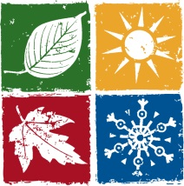
The days get shorter and colder in…
People wear T-shirts, shorts, swimsuits in…
There is fog and drizzly in…
Temperatures are from 25⁰C to 30⁰C in …

The nights are longer than the days in…
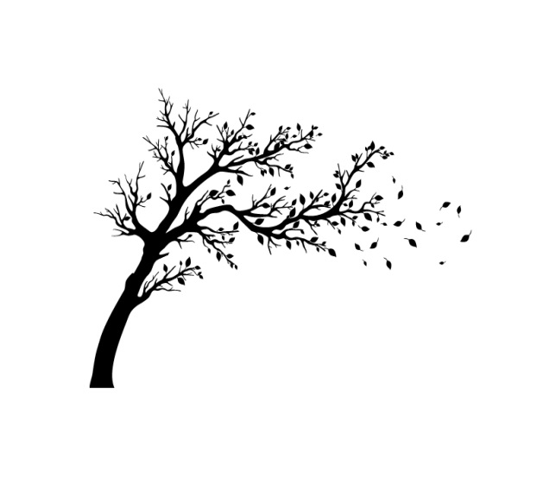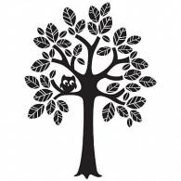This season begins on the 23rd September…
