National Holidays
4th Thursday in November
28th October
25th December
1st January
31st December
14th February
24th December
28th September
4th July
8th May
31st October
March or April

A lot of drinking, parties and fireworks.
Time of masks, costumes and superstitions.
It is the oldest of all American holidays.
People in UK and the USA open presents.
The Czechoslovak Republic was founded in 1918.
People celebrate the resurrection of Jesus Christ.
People in love give and get candies and gifts.
On this day Prince Wenceslas was killed.
People celebrate the end of the Second World War in1945.
People make New Year´s resolutions.
Americans celebrate their country’s birthday.
People in CR open presents under Christmas tree.
1. Thanksgiving Day
2. New Year´s Day
3. Liberation Day
4. Christmas Eve
5. Easter
6. Christmas Day
7. US Independence Day
8. Halloween
9. Saint Valentine's Day
10. New Year’s Eve
11. Czech Statehood Day
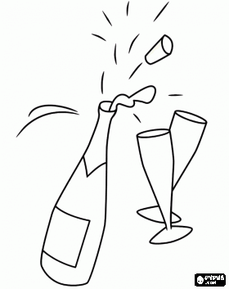
12. Czechoslovak Independence Day

