Meals
People usually have three meals a day: breakfast in the morning,lunch at noon and ……………in the evening. Some people like snack, too.

Daily meals usually start with breakfast. For breakfast we can have roll or bread,
tea with lemon and sugar, coffee with milk or cocoa. Some people eat cereals.
I have breakfast every weekday at ……………. My favourite breakfast is ………………………
I usually drink……………………………………………….in the morning.

Next meal is snack. I take it during a break after the second lesson; my mum
prepares it for me. For snack I can have ………………………………………………………………………….

At noon people have their …………. In the Czech Republic it is the main meal of the day and it has three courses: soup, a main course, and a dessert. I know many kinds of soups, for example......................................and.................soup. My favourite soup is…………………………….
There are different types of meat, for example.............................................. meat.
As a side dish we can have...........................................................I prefer….……………………………….
Dessert can be ……………………………......................For me the best dessert is……………………………..

The evening meal is called …………... It may be some salami and ham, cheese, eggs, bread or rolls and some vegetables. We can also have pancakes, potato pancakes, pizza or goulash. I usually have ………………………………………………………………………………….. for dinner.

We know many kinds of drinks - hot or cold drinks, alcoholic or non-alcoholic drinks.
Hot drinks are.........................
Cold drinks are.................................
From alcoholic drinks I know.......................
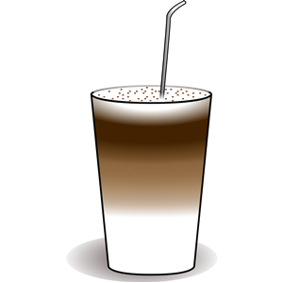
Non-alcoholic drinks are.......................
My favourite drink is………………
