National Cuisines
(Národní kuchyně)

Eating out
If we want to eat out, we can go to:
Pizzeria Barbecue restaurant Steak house
Vegetarian restaurant Chinese restaurant Italian restaurant
We can have a drink in:
Pub Coffee house
Snack bar Bakery café
Wine bar Tea house

Czech National Meals and Beverages

Typical Czech dishes are:
Pork with dumplings and cabbage/sauerkraut
Beef with dumplings, cream sauce and cranberries
Pork schnitzel
Fried Cheese
Goulash

Typical Czech sweet dishes are:
Fruit dumplings (plums, strawberries…)
Apple Strudel
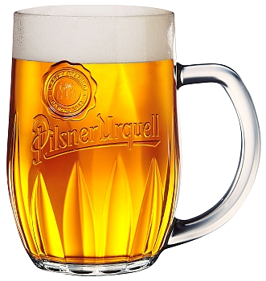
Honey cake

Czech Christmas meal consists of:
Fish soup
Fried carp with potato salad
Christmas cookies, Christmas cake and gingerbread

The Czech most popular drink is beer.
Next popular drinks are wine from Moravia, Becherovka, slivovice
English National Meals and Beverages

English Breakfast
A full English breakfast consists of bacon, eggs, tomatoes, fried mushrooms, sausages and toast. British traditional drink is tea with milk.
Sometimes British have brunch – it is breakfast and lunch together.

English lunch:
It is lighter meal. It is often just a sandwich or salad or so- called “packed lunch” consisting of a sandwich, a packet of crisps, a piece of fruit and a drink.

Typical English dishes are:
Fish and Chips
Roast meat (beef, pork or lamb)
Cottage Pie (minced beef and vegetables with mashed potatos)
Yorkshire Pudding (baked batter served with roast beef and gravy)

English Christmas meal is:
Roast turkey served with roast potatoes and vegetables.
The Christmas pudding

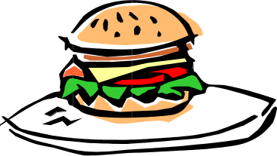
American National Meals and Beverages

Fast food is a typical feature of American life style.
Famous fast foods are McDonald’s, Burger King, KFC.
Typical American drink is Coca Cola.

American Christmas meal is:
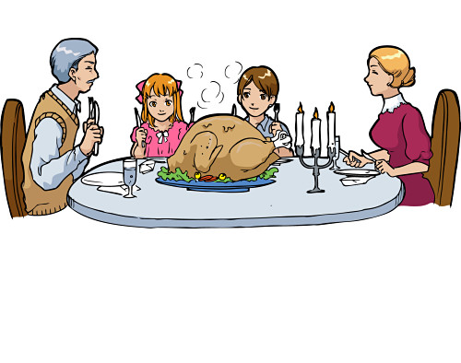
Roast turkey served with roast potatoes and vegetables and Apple Pie

